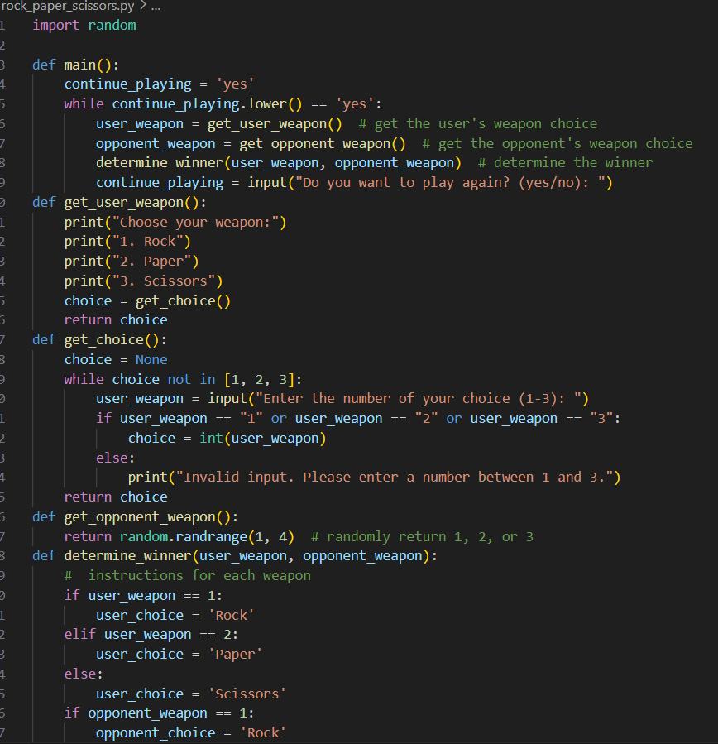

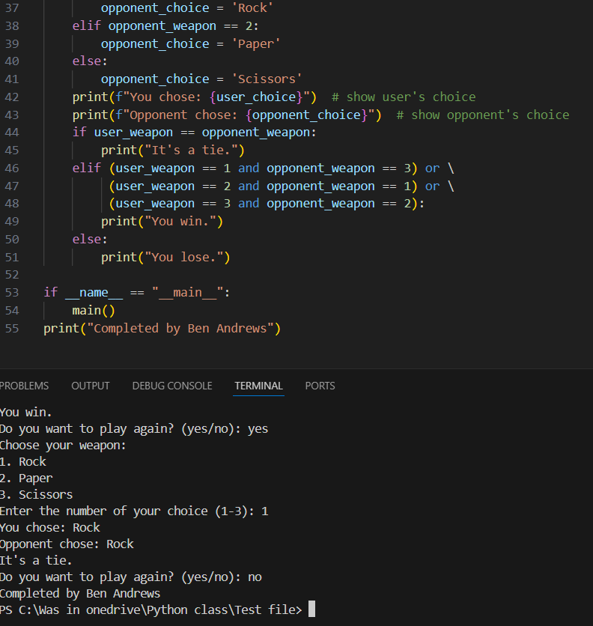

import random

def main():

continue_playing = 'yes'

while continue_playing.lower() == 'yes':

user_weapon = get_user_weapon() # get the user's weapon choice

opponent_weapon = get_opponent_weapon() # get the opponent's weapon choice

determine_winner(user_weapon, opponent_weapon) # determine the winner

continue_playing = input("Do you want to play again? (yes/no): ")

def get_user_weapon():

print("Choose your weapon:")

print("1. Rock")

print("2. Paper")

print("3. Scissors")

choice = get_choice()

return choice

def get_choice():

choice = None

while choice not in [1, 2, 3]:

user_weapon = input("Enter the number of your choice (1-3): ")

if user_weapon == "1" or user_weapon == "2" or user_weapon == "3":

choice = int(user_weapon)

else:

print("Invalid input. Please enter a number between 1 and 3.")

return choice

def get_opponent_weapon():

return random.randrange(1, 4) # randomly return 1, 2, or 3

def determine_winner(user_weapon, opponent_weapon):

# instructions for each weapon

if user_weapon == 1:

user_choice = 'Rock'

elif user_weapon == 2:

user_choice = 'Paper'

else:

user_choice = 'Scissors'

if opponent_weapon == 1:

opponent_choice = 'Rock'

elif opponent_weapon == 2:

opponent_choice = 'Paper'

else:

opponent_choice = 'Scissors'

print(f"You chose: {user_choice}") # show user's choice

print(f"Opponent chose: {opponent_choice}") # show opponent's choice

if user_weapon == opponent_weapon:

print("It's a tie.")

elif (user_weapon == 1 and opponent_weapon == 3) or \

(user_weapon == 2 and opponent_weapon == 1) or \

(user_weapon == 3 and opponent_weapon == 2):

print("You win.")

else:

print("You lose.")

if __name__ == "__main__":

main()

print("Completed by Ben Andrews")